Name: Arka Haldi
UID: 2018130014
Date: 7/11/20
CEL 51, DCCN, Monsoon 2020
Lab 8: Socket Programming

Socket Programming
- Sockets are the endpoints of a bidirectional communications channel. Sockets may communicate within a process, between processes on the same machine, or between processes on different continents. We use the socket module in python to create and use sockets.
- Python provides two levels of access to network services. At a low level, you can access the basic socket support in the underlying operating system, which allows you to implement clients and servers for both connection-oriented and connectionless protocols.
- Python also has libraries that provide higher-level access to specific application-level network protocols, such as FTP, HTTP, and so on.
Sockets have their own vocabulary −
Sr.No. | Term & Description
1 | Domain  The family of protocols that is used as the transport mechanism. These values are constants such as AF_INET, PF_INET, PF_UNIX, PF_X25, and so on.
2 | type  The type of communications between the two endpoints, typically SOCK_STREAM for connection-oriented protocols and SOCK_DGRAM for connectionless protocols.
3 | protocol  Typically zero, this may be used to identify a variant of a protocol within a domain and type.
4 | hostname  The identifier of a network interface −  - A string, which can be a host name, a dotted-quad address, or an IPV6 address in colon (and possibly dot) notation  - A string "<broadcast>", which specifies an INADDR_BROADCAST address.  - A zero-length string, which specifies INADDR_ANY, or  - An Integer, interpreted as a binary address in host byte order.
5 | port  Each server listens for clients calling on one or more ports. A port may be a Fixnum port number, a string containing a port number, or the name of a service.

The socket Module
- To create a socket, you must use the socket.socket() function available in socket module, which has the general syntax −
s = socket.socket (socket_family, socket_type, protocol=0)
- Here is the description of the parameters −
  - socket_family − This is either AF_UNIX or AF_INET, as explained earlier.
  - socket_type − This is either SOCK_STREAM or SOCK_DGRAM.
  - protocol − This is usually left out, defaulting to 0.
- Once you have socket object, then you can use required functions to create your client or server program.

Server Socket Methods
Sr.No. | Method & Description
1 | s.bind()  This method binds address (hostname, port number pair) to socket.
2 | s.listen()  This method sets up and start TCP listener.
3 | s.accept()  This passively accept TCP client connection, waiting until connection arrives (blocking).

Client Socket Methods
Sr.No. | Method & Description
1 | s.connect()  This method actively initiates TCP server connection.

General Socket Methods
Sr.No. | Method & Description
1 | s.recv()  This method receives TCP message
2 | s.send()  This method transmits TCP message
3 | s.recvfrom()  This method receives UDP message
4 | s.sendto()  This method transmits UDP message
5 | s.close()  This method closes socket
6 | socket.gethostname()  Returns the hostname.

CODE :

SERVER.py
import socket
# create a socket, with AF_INET : Address from the internet
# AF_INET accepts two params : host address and port number
# SOCK_STREAM used to create TCP protocols
s = socket.socket(socket.AF_INET, socket.SOCK_STREAM)

# gethostname is used when client and server are on the same device
# bind the server to the client
s.bind((socket.gethostname(), 1025)) # >1023 ----> Non - privilege address
# Enter the listening mode
s.listen(5)
# for every connection
while True :
clt,addr = s.accept()
print(f'Connection to {addr} established!')
# pass a message to the connected client
clt.send(bytes('Socket programming in python!','utf-8'))
clt.close()
# end the connection and keep listening

CLIENT.py
import socket
# create a socket, with AF_INET : Address from the internet
# AF_INET accepts two params : host address and port number
# SOCK_STREAM used to create TCP protocols
s = socket.socket(socket.AF_INET, socket.SOCK_STREAM)

# using the localhost and the port number allowed on the server
# open a connection to the port on that address
s.connect((socket.gethostname(), 1025)) # connect to the server port

full_message = ''
# limit on the number of bytes read from the server at a time
n_bytes = 6

while True:
msg = s.recv(n_bytes) # message received, with limit on socket
print(msg.decode('utf-8'), len(msg)) # print the information received
full_message += msg.decode('utf-8') # append to the full_message
if len(msg) < n_bytes :
break # close the connection, once the message is received

print(full_message)

Testing telnet on the server, if it works
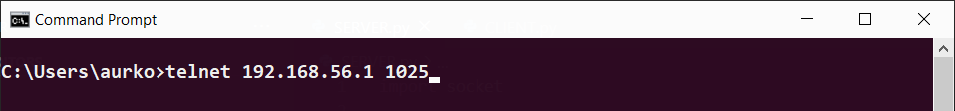
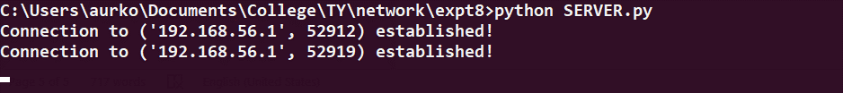
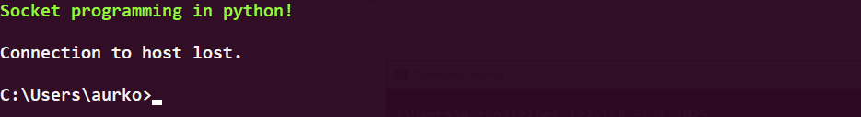

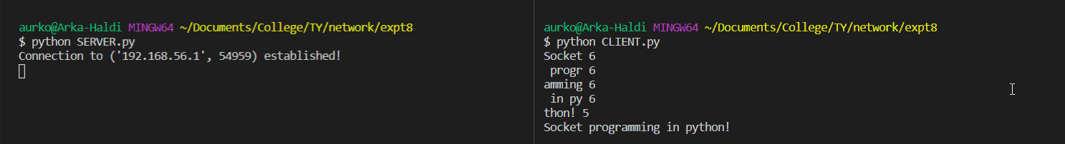
After success, we test our CLIENT.py to connect to the server..

- As we see, our program works as expected and sends a message in packets of length 6 bytes, and reassembles it at the client side, demonstrating the use of socket programming using Telnet.

Conclusion
- I understood how to successfully establish a connection between client and server using socket programming.
References
- https://www.geeksforgeeks.org/socket-programming-python/
- https://www.youtube.com/watch?v=T0rYSFPAR0A
- https://www.tutorialspoint.com/unix_sockets/what_is_socket.htm
- https://www.tutorialspoint.com/python_network_programming/python_sockets_programming.htm

